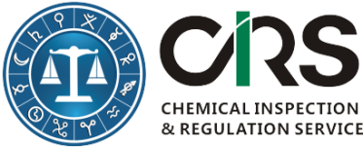
CHEMICAL INSPECTION & REGULATION SERVICE LTD.
杭州瑞旭产品技术有限公司（CIRS China）
TEL: + 86 571 87206555 | FAX: +86 571 87206533
WEBSITE: http://www.cirs-group.com

Workshop Registration Form

Attendee Information
First Name(*):
Last Name(*):
Email (*):
Company or Organization(*):
No. of Attendees and Their Names:
Telephone:
Pre-submitted Questions About Japanese
Chemical Regulations
* Mandatory Fields
- Please send this form to sj@cirs-group.com after it is completed; or contact +86 571 87206590 for assistance;
- After receiving this form, we will send you our bank information and confirm your registration;
- Cash is also accepted.

